3rd Annual
Age- and Dementia-Friendly Winnemucca and Humboldt County
&
Humboldt Volunteer Hospice
Sprint Triathlon
When: Saturday, September 18, 2021 – Bode Howard Pool and then around and about Winnemucca
Registration and shirt/packet pick-up 6:30-7:00 am
Swimming begins at 7:00
Where: Swim – Bode Howard Pool (1/3-mile)
Bike – 12-mile double loop from pool to Winger’s, around neighborhoods to Offenhauser, down Highland to Mizpah return to pool area for second loop
Run – from pool clockwise loop to Winnemucca Blvd, Highland, Hansen, then Haskell to pool (3.75-mile).
Cost: $30 per registrant

All proceeds will be used for Alzheimer’s Awareness, creation of the Appreciation Wall by the Fitness Park walkway, expansion at Community Garden, or Hospice.

For more information and to register contact:
ginilc25@gmail.com
www.adf-winnemucca.com
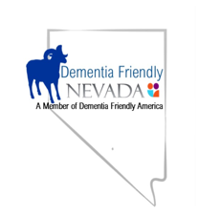
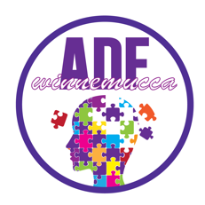
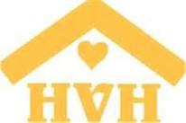

I, ______________________________, release Dementia Friendly Nevada, Humboldt Volunteer Hospice, and Age- and Dementia-Friendly Winnemucca and Humboldt County from any liability during the Sprint Triathlon to be held September 18, 2021.

I plan to participate in the (circle all that apply): swim bike jog/run

If you are on a team, please name the other team members and in which portion of the Sprint Triathlon each is participating: __________________; __________________

Contact information (name/email/phone #):

